SPEI Estimation

**Methodology**

The SPEI’s are estimated using the SPEI package of R programming languages. For concise estimation, monthly data of five stations- Bogra, Dinajpur, Ishwardi, Rajshahi, and Rangpur- were averaged out. Then Potential evapotranspiration (PET) values were estimated using Thornthwaite equation. For this, latitudes of the regions were also needed. Then climatic water balances (BAL) were calculated by subtracting PET from Monthly Precipitation Totals, in mm (PRCP).

Finally, 12 months SPEI values were calculated using the SPEI package.

The negative SPEIs are related to the dry condition; a drought event is defined when the SPEI is continuously negative and reaches a value of “−1.0” or less.

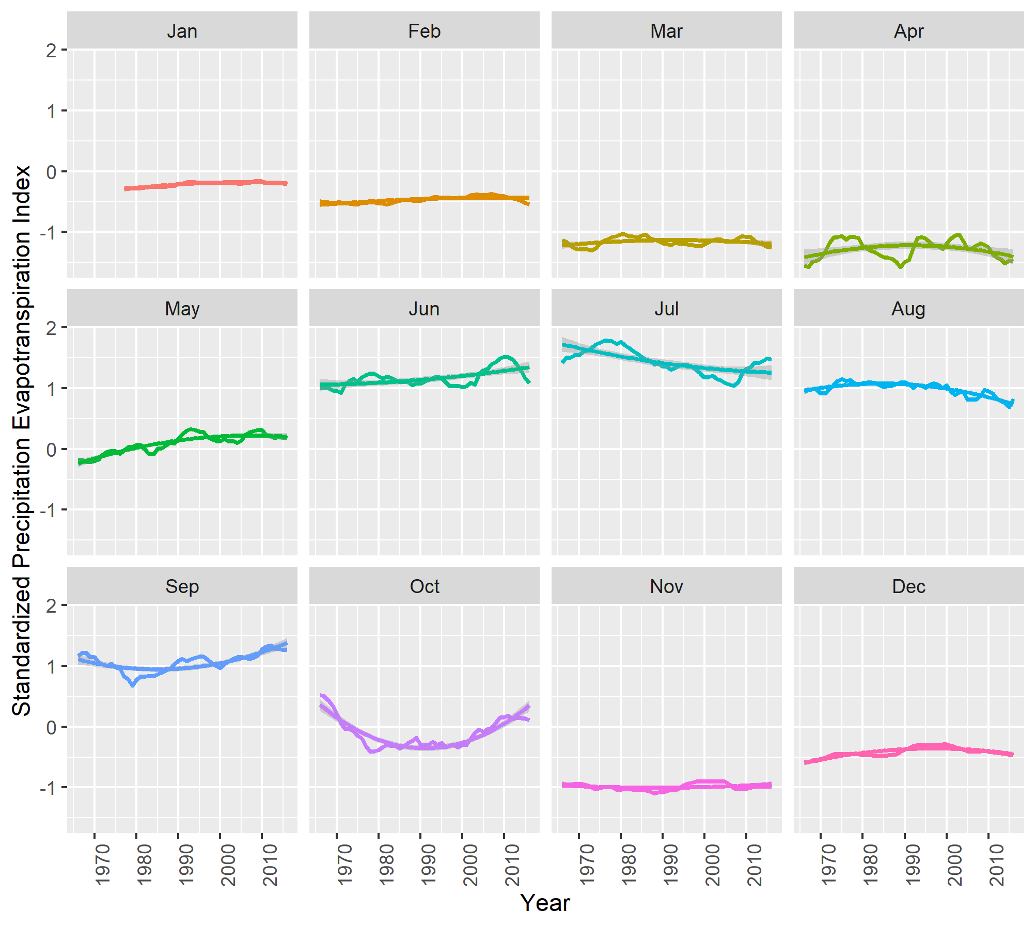

**Interpretation**

The figure shows that drought is most prevalent during the months of March, April, and November. Slight dry conditions are also seen during the months of December, February, and January (in order of less severity). Other months experienced heavy rainfall, especially the months of June and July. Over the years, rainfall increased in September. Rainfall in October followed a U-shaped pattern, decreasing since 1966 and again increasing after 1990s. The months of January, February, March, and November remained approximately constant through the years in terms of SPEI values.

**Aridty Index**

